Ponte Vecchio

The **Ponte Vecchio** ("Old Bridge", Italian pronunciation: [[ˈponte ˈvɛkkjo]](https://en.wikipedia.org/wiki/Help:IPA/Italian))[[1]](https://en.wikipedia.org/wiki/Ponte_Vecchio#cite_note-pv-1)[[2]](https://en.wikipedia.org/wiki/Ponte_Vecchio#cite_note-2) is a [medieval](https://en.wikipedia.org/wiki/Middle_Ages) stone closed-[spandrel](https://en.wikipedia.org/wiki/Spandrel) [segmental](https://en.wikipedia.org/wiki/Circular_segment) [arch bridge](https://en.wikipedia.org/wiki/Arch_bridge) over the [Arno River](https://en.wikipedia.org/wiki/Arno_River), in [Florence](https://en.wikipedia.org/wiki/Florence,_Italy), Italy. It is noted for the shops built along it; building shops on such bridges was once a common practice. Butchers, tanners, and farmers initially occupied the shops; the present tenants are jewelers, art dealers, and souvenir sellers.[[3]](https://en.wikipedia.org/wiki/Ponte_Vecchio#cite_note-dupre-3) The Ponte Vecchio's two neighboring bridges are the [Ponte Santa Trinita](https://en.wikipedia.org/wiki/Ponte_Santa_Trinita) and the [Ponte alle Grazie](https://en.wikipedia.org/wiki/Ponte_alle_Grazie).

The bridge connects via Por Santa Maria (Lungarno degli Acciaiuoli and Lungarno degli Archibusieri) to via de 'Guicciardini (Borgo San Jacopo and via de' Bardi).

The name was given to what was the oldest Florentine bridge when the bridge to the Carraia was built, then called "Ponte Nuovo" in contrast to the pons Vetus. Beyond the historical value, the bridge over time has played a central role in the city road system, starting from when it connected the Roman Florentia with the Via Cassia Nuova commissioned by the emperor Hadrian in 123 AD.

In contemporary times, despite being closed to vehicular traffic, the bridge is crossed by a considerable pedestrian flow generated both by the notoriety of the place itself and by the fact that it connects places of high tourist interest on the two banks of the river: [piazza del Duomo](https://en.wikipedia.org/wiki/Piazza_del_Duomo,_Florence), piazza della Signoria on one side with the area of [Palazzo Pitti](https://en.wikipedia.org/wiki/Palazzo_Pitti) and [Santo Spirito](https://en.wikipedia.org/wiki/Santo_Spirito,_Florence) in the [Oltrarno](https://en.wikipedia.org/wiki/Oltrarno" \o "Oltrarno).

The bridge appears in the list drawn up in 1901 by the General Directorate of Antiquities and Fine Arts, as a monumental building to be considered national artistic heritage.

History and construction[[edit](https://en.wikipedia.org/w/index.php?title=Ponte_Vecchio&action=edit&section=1" \o "Edit section: History and construction)]

The bridge spans the Arno at its narrowest point[[4]](https://en.wikipedia.org/wiki/Ponte_Vecchio#cite_note-tci-4) where it is believed that a bridge was first built in [Roman](https://en.wikipedia.org/wiki/Ancient_Rome) times,[[5]](https://en.wikipedia.org/wiki/Ponte_Vecchio#cite_note-arch-5) when the [via Cassia](https://en.wikipedia.org/wiki/Via_Cassia) crossed the river at this point.[[4]](https://en.wikipedia.org/wiki/Ponte_Vecchio#cite_note-tci-4) The Roman piers were of stone, the superstructure of wood.[[*citation needed*](https://en.wikipedia.org/wiki/Wikipedia:Citation_needed)] The bridge first appears in a document of 996[[4]](https://en.wikipedia.org/wiki/Ponte_Vecchio#cite_note-tci-4) and was destroyed by a [flood](https://en.wikipedia.org/wiki/Flood) in 1117[[3]](https://en.wikipedia.org/wiki/Ponte_Vecchio#cite_note-dupre-3) and reconstructed in stone. In 1218 the Ponte alla Carraia, a wooden structure, was established nearby which led to it being referred to as "Ponte Nuovo" relative to the older (Vecchio) structure.[[3]](https://en.wikipedia.org/wiki/Ponte_Vecchio#cite_note-dupre-3) It was swept away again in 1333[[5]](https://en.wikipedia.org/wiki/Ponte_Vecchio#cite_note-arch-5) except for two of its central piers, as noted by [Giovanni Villani](https://en.wikipedia.org/wiki/Giovanni_Villani) in his [*Nuova Cronica*](https://en.wikipedia.org/wiki/Nuova_Cronica).[[6]](https://en.wikipedia.org/wiki/Ponte_Vecchio#cite_note-6) It was rebuilt in 1345.[[7]](https://en.wikipedia.org/wiki/Ponte_Vecchio#cite_note-7)

[Giorgio Vasari](https://en.wikipedia.org/wiki/Giorgio_Vasari) recorded the traditional view of his day that attributed its design to [Taddeo Gaddi](https://en.wikipedia.org/wiki/Taddeo_Gaddi)[[1]](https://en.wikipedia.org/wiki/Ponte_Vecchio#cite_note-pv-1)— besides Giotto one of the few artistic names of the [trecento](https://en.wikipedia.org/wiki/Trecento" \o "Trecento) still recalled two hundred years later. Modern historians present Neri di Fioravanti as a possible candidate as builder.[[4]](https://en.wikipedia.org/wiki/Ponte_Vecchio#cite_note-tci-4)

Sheltered in a little loggia at the central opening of the bridge is a weathered dedication stone, which once read *Nel trentatrè dopo il mille-trecento, il ponte cadde, per diluvio dell' acque: poi dieci anni, come al Comun piacque, rifatto fu con questo adornamento*.[[8]](https://en.wikipedia.org/wiki/Ponte_Vecchio#cite_note-8) The [Torre dei Mannelli](https://en.wikipedia.org/wiki/Torre_dei_Mannelli) was built at the southeast corner of the bridge to defend it.

The bridge consists of three segmental arches: the main arch has a span of 30 meters (98 feet) the two side arches each span 27 meters (89 feet). The rise of the arches is between 3.5 and 4.4 meters (11½ to 14½ feet), and the span-to-rise ratio 5:1.[[9]](https://en.wikipedia.org/wiki/Ponte_Vecchio#cite_note-structurae-9) The shallow segmental arches, which require fewer piers than the [semicircular](https://en.wikipedia.org/wiki/Semicircular) arch traditionally used by Romans, enabled ease of access and navigation for animal-drawn carts.[[3]](https://en.wikipedia.org/wiki/Ponte_Vecchio#cite_note-dupre-3) Another notable design element is the large [piazza](https://en.wikipedia.org/wiki/Piazza) at the center of the bridge that [Leon Battista Alberti](https://en.wikipedia.org/wiki/Leon_Battista_Alberti) described as a prominent ornament in the city.[[3]](https://en.wikipedia.org/wiki/Ponte_Vecchio#cite_note-dupre-3)

A stone with an inscription from [Dante](https://en.wikipedia.org/wiki/Dante) ([*Paradiso*](https://en.wikipedia.org/wiki/Paradiso_(Dante)) xvi. 140-7) records the spot at the entrance to the bridge where [Buondelmonte de' Buondelmonti](https://en.wikipedia.org/wiki/Buondelmonte_de%27_Buondelmonti" \o "Buondelmonte de' Buondelmonti) was murdered by the [Amidei](https://en.wikipedia.org/wiki/Amidei" \o "Amidei) clan in 1215, which began the urban fighting of the [Guelfs and Ghibellines](https://en.wikipedia.org/wiki/Guelfs_and_Ghibellines).

The bridge has always hosted shops and merchants who displayed their goods on tables before their premises, after authorization by the [Bargello](https://en.wikipedia.org/wiki/Bargello) (a sort of a lord mayor, a magistrate and a police authority).

Later additions and changes[[edit](https://en.wikipedia.org/w/index.php?title=Ponte_Vecchio&action=edit&section=2" \o "Edit section: Later additions and changes)]

[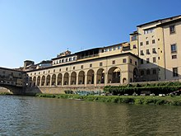](https://en.wikipedia.org/wiki/File:Lungarno_degli_archibugieri_(corridoio_vasariano)_visto_dal_fiume_01.JPG)

[Vasari Corridor](https://en.wikipedia.org/wiki/Vasari_Corridor) from [Palazzo Vecchio](https://en.wikipedia.org/wiki/Palazzo_Vecchio) to [Palazzo Pitti](https://en.wikipedia.org/wiki/Palazzo_Pitti)

In order to connect the [Palazzo Vecchio](https://en.wikipedia.org/wiki/Palazzo_Vecchio) (Florence's town hall) with the [Palazzo Pitti](https://en.wikipedia.org/wiki/Palazzo_Pitti), in 1565 [Cosimo I de' Medici](https://en.wikipedia.org/wiki/Cosimo_I_de%27_Medici" \o "Cosimo I de' Medici) had [Giorgio Vasari](https://en.wikipedia.org/wiki/Giorgio_Vasari) build the [Vasari Corridor](https://en.wikipedia.org/wiki/Vasari_Corridor), part of which runs above the Ponte Vecchio.[[5]](https://en.wikipedia.org/wiki/Ponte_Vecchio#cite_note-arch-5)

To enhance the prestige and clean up the bridge, a decree was made in 1595 that excluded butchers from this bridge (only goldsmiths and jewelers are allowed) that is in effect to this day.[[10]](https://en.wikipedia.org/wiki/Ponte_Vecchio#cite_note-10) The association of butchers had monopolized the shops on the bridge since 1442.

The back shops (*retrobotteghe*) that may be seen from upriver were added in the seventeenth century.[[4]](https://en.wikipedia.org/wiki/Ponte_Vecchio#cite_note-tci-4)

20th century[[edit](https://en.wikipedia.org/w/index.php?title=Ponte_Vecchio&action=edit&section=3" \o "Edit section: 20th century)]

In 1900, to honor and mark the fourth century of the birth of the great Florentine sculptor and master goldsmith [Benvenuto Cellini](https://en.wikipedia.org/wiki/Benvenuto_Cellini" \o "Benvenuto Cellini), the leading goldsmiths of the bridge commissioned the Florentine sculptor, [Raffaello Romanelli](https://en.wikipedia.org/wiki/Raffaello_Romanelli" \o "Raffaello Romanelli), to create a bronze bust of Cellini to stand atop a fountain in the middle of the Eastern side of the bridge, where it stands to this day.[[11]](https://en.wikipedia.org/wiki/Ponte_Vecchio#cite_note-11)

[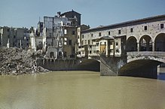](https://en.wikipedia.org/wiki/File:Scenes_in_Florence,_Italy,_14_August_1944_TR2286.jpg)

Damage shown shortly after liberation in August 1944 during World War II

During [World War II](https://en.wikipedia.org/wiki/World_War_II), the Ponte Vecchio was not destroyed by the German army during their retreat at the advance of the British [8th Army](https://en.wikipedia.org/wiki/Eighth_Army_(United_Kingdom)) on 4 August 1944, unlike all the other bridges in Florence.[[12]](https://en.wikipedia.org/wiki/Ponte_Vecchio#cite_note-12)[[13]](https://en.wikipedia.org/wiki/Ponte_Vecchio#cite_note-13) This was, according to many locals and tour guides, because of an express order by [Hitler](https://en.wikipedia.org/wiki/Hitler).[[14]](https://en.wikipedia.org/wiki/Ponte_Vecchio#cite_note-14)[[15]](https://en.wikipedia.org/wiki/Ponte_Vecchio#cite_note-15)[[16]](https://en.wikipedia.org/wiki/Ponte_Vecchio#cite_note-16) Access to the Ponte Vecchio was, however, obstructed by the destruction of the buildings at both ends of the bridge, which have since been rebuilt using a combination of original and modern designs.

The bridge was severely damaged in the [1966 flood of the Arno](https://en.wikipedia.org/wiki/1966_Flood_of_the_River_Arno_in_Florence).[[17]](https://en.wikipedia.org/wiki/Ponte_Vecchio#cite_note-17)

Between 2005 and 2006, 5,500 padlocks, known as [love locks](https://en.wikipedia.org/wiki/Love_locks), which were attached to the railings around the bust of Cellini, were removed by the city council. According to the council, the padlocks were aesthetically displeasing and damaged the bust and its railings. There is now a fine for attaching love locks to the bridge.[[18]](https://en.wikipedia.org/wiki/Ponte_Vecchio#cite_note-flor-18)

Panorama[[edit](https://en.wikipedia.org/w/index.php?title=Ponte_Vecchio&action=edit&section=4" \o "Edit section: Panorama)]

[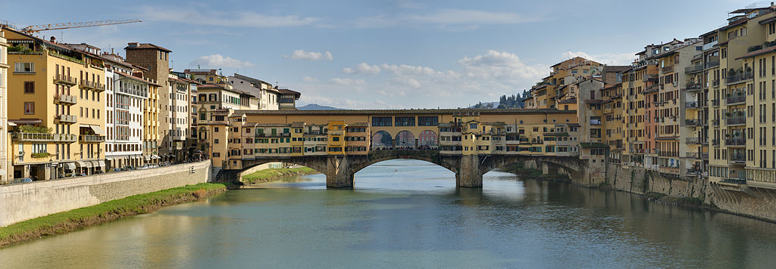](https://en.wikipedia.org/wiki/File:Panorama_of_the_Ponte_Vecchio_in_Florence,_Italy.jpg)

Panoramic view of the Ponte Vecchio, from the west.

In art[[edit](https://en.wikipedia.org/w/index.php?title=Ponte_Vecchio&action=edit&section=5" \o "Edit section: In art)]

* The bridge is mentioned in the aria "[O mio babbino caro](https://en.wikipedia.org/wiki/O_mio_babbino_caro)" by [Giacomo Puccini](https://en.wikipedia.org/wiki/Giacomo_Puccini).
* Wall [mural](https://en.wikipedia.org/wiki/Mural) in [Grossi Florentino](https://en.wikipedia.org/wiki/Grossi_Florentino" \o "Grossi Florentino), executed by students of [Napier Waller](https://en.wikipedia.org/wiki/Napier_Waller) under supervision

[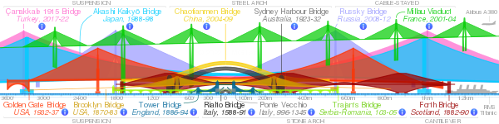](https://en.wikipedia.org/wiki/File:Comparison_of_notable_bridges_SMIL.svg)

Comparison of the side elevations of the *Ponte Vecchio* and some notable bridges at the same scale. [(click for interactive version)](https://upload.wikimedia.org/wikipedia/commons/3/37/Comparison_of_notable_bridges_SMIL.svg)Architecture

Interesting facts about the Ponte Vecchio

The **Ponte Vecchio** is a medieval stone closed-spandrel segmental arch bridge over the Arno River, in [Florence](http://justfunfacts.com/interesting-facts-about-florence/), [Italy](http://justfunfacts.com/interesting-facts-about-italy/).

The Ponte Vecchio, meaning **“Old Bridge”** in Italian, is the **oldest bridge in Florence**.

It is also the **first segmental arch bridge** built in the West.

The bridge is an **outstanding engineering achievement** of the **European Middle Ages**.

The Ponte Vecchio is **noted for still having shops built along it**, as was once common.

The bridge is **84 meters** (276 feet) **long** and **32 meters** (105 feet) **wide**.

It consists of **three segmental arches**: the main arch has a span of 30 meters (98 feet) the two side arches each span 27 meters (89 feet). The rise of the arches is between 3.5 and 4.4 meters (11.5 to 14.5 feet), and the span-to-rise ratio 5:1.

[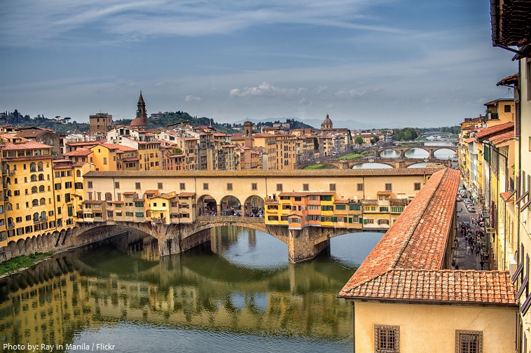](http://justfunfacts.com/wp-content/uploads/2018/03/ponte-vecchio-2.jpg)

Built very close to the Roman crossing, the Ponte Vecchio was the only bridge across the Arno in Florence until 1218.

After being destroyed by a flood in 1117 it was reconstructed in stone but swept away again in 1333 save two of its central piers, as noted by Giovanni Villani in his Nuova Cronica. **The current bridge was rebuilt in 1345**.

**It is not known who is the designer of today’s bridge** but it is believed that it is **Taddeo Gaddi** or **Neri di Fioravanti**.

One of its characteristics, **shops**, are there since the beginning and were first populated with butcher shops and tanners but in 1593 duke Ferdinand I decided to allow only goldsmiths and jewelers to hold shops on Ponte Vecchio because former tenants produced too much garbage and foul smells. The present tenants are jewelers, art dealers and souvenir sellers.

The **back shops** (retrobotteghe) that may be seen from upriver, were added in the seventeenth century.

When the Medici moved from Palazzo Vecchio to Palazzo Pitti, they decided they needed a connecting route from the Uffizi to the Palazzo Pitti on the other side of the Arno that would enable them to keep out of contact with the people they ruled. The result was the **Corridoio Vasariano**, built in 1565 by Giorgio Vasari and which runs above the little goldsmiths’ shops on the Ponte Vecchio.

During **World War II** the Ponte Vecchio bridge over the Arno River was the only one spared from destruction by the retreating German army. This was allegedly, according to many locals and tour guides, because of an express order by Hitler.

[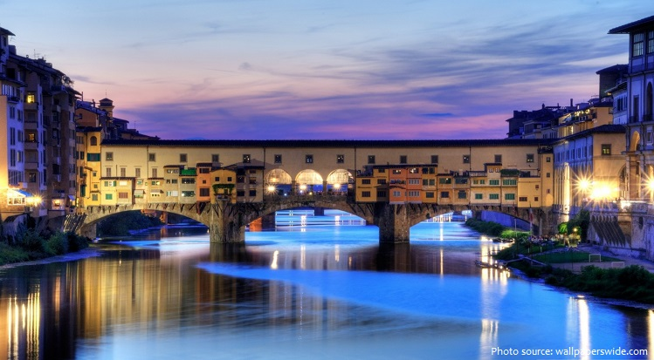](http://justfunfacts.com/wp-content/uploads/2018/03/ponte-vecchio-3.jpg)

**It is said that the economic concept of bankruptcy originated here**: when a money-changer could not pay his debts, the table on which he sold his wares (the “banco”) was physically broken (“rotto”) by soldiers, and this practice was called “bancorotto” (broken table; possibly it can come from “banca rotta” which means “broken bank”). Not having a table anymore, the merchant was not able to sell anything.

In 1900, to honour and mark the fourth century of the birth of the great Florentine sculptor and master goldsmith Benvenuto Cellini, the leading goldsmiths of the bridge commissioned the most renowned Florentine sculptor of the time Raffaello Romanelli to create a bronze bust of Cellini to stand atop a fountain in the middle of the Eastern side of the bridge, where it stands to this day.

There is a relatively recent custom, in which couples declare their “eternal love” by placing a lock on Cellini’s monument.

The Ponte Vecchio’s two neighbouring bridges are the Ponte Santa Trinita and the Ponte alle Grazie.

|  |  |
| --- | --- |
| **Ponte Vecchio** | |
| [Ponte Vecchio from Ponte alle Grazie.jpg](https://en.wikipedia.org/wiki/File:Ponte_Vecchio_from_Ponte_alle_Grazie.jpg) | |
| [**Coordinates**](https://en.wikipedia.org/wiki/Geographic_coordinate_system) | https://upload.wikimedia.org/wikipedia/commons/thumb/5/55/WMA_button2b.png/17px-WMA_button2b.png[43°46′05″N 11°15′11″E](https://geohack.toolforge.org/geohack.php?pagename=Ponte_Vecchio&params=43.76799_N_11.25316_E_type:landmark_region:IT-FI)[Coordinates](https://en.wikipedia.org/wiki/Geographic_coordinate_system): https://upload.wikimedia.org/wikipedia/commons/thumb/5/55/WMA_button2b.png/17px-WMA_button2b.png[43°46′05″N 11°15′11″E](https://geohack.toolforge.org/geohack.php?pagename=Ponte_Vecchio&params=43.76799_N_11.25316_E_type:landmark_region:IT-FI) |
| **Crosses** | [Arno River](https://en.wikipedia.org/wiki/Arno_River) |
| **Locale** | [Florence](https://en.wikipedia.org/wiki/Florence,_Italy), Italy |
| **Characteristics** | |
| **Design** | closed-[spandrel](https://en.wikipedia.org/wiki/Spandrel) segmental stone [arch bridge](https://en.wikipedia.org/wiki/Arch_bridge) |
| **Width** | 32 metres (105 ft) |
| **Longest span** | 30 metres (98 ft) |
| **Location** | |
| [[https://maps.wikimedia.org/img/osm-intl,10,43.76799,11.25316,270x200.png?lang=en&domain=en.wikipedia.org&title=Ponte+Vecchio&groups=_660bcbe4012fadae9b391d13b0a653536f2fb33e](https://en.wikipedia.org/wiki/Ponte_Vecchio#/map/0)](https://en.wikipedia.org/wiki/Ponte_Vecchio" \l "/map/0)  [Wikimedia](https://foundation.wikimedia.org/wiki/Maps_Terms_of_Use) | © [OpenStreetMap](https://www.openstreetmap.org/copyright) | |